**Attenuation of the Toxic Side Effects of Chemotherapy and Statin Treatment**

|  |  |
| --- | --- |
| **Project Number:** | #1686 |
| **Principal Investigator:** | Prof. Menachem Rubinstein |
| **Patent Status:** | Pending |

**Overview**

Modern drug therapy has been a great boon to human health. However, many drugs used in chemotherapy for example, frequently have debilitating side effects, as normal cells are also affected by chemotherapy, thereby limiting the treatment efficacy. The common theme is the induction of endoplasmic reticulum (ER) stress through these compounds, triggering related apoptotic and necrotic cell death pathways. The new technology is based on the discovery that inhibition of key components of the recently discovered MGST2-LTC4 signalling pathway is an effective means of attenuating the toxic side effects of chemotherapy and statin treatment when applied in combination, whilst still preserving the effectiveness of the treatments.

**Toxic Side Effects of Chemotherapy and Statin Treatment - The Unmet Medical Need**

Chemotherapy is one of the most frequently used options for the treatment of a broad range of cancers, due to its selectivity towards rapidly dividing cells. However, normal cells are also affected by chemotherapy, leading to severe side effects. Damage to bone marrow cells results in thrombocytopenia, neutropenia, and immunosuppression. Damage to epithelial and endothelial cells in the gastrointestinal tract results in ulceration, nausea and diarrhea. Chemotherapy may also cause serious damage to the kidneys, trigger neuropathy and even heart failure, all quite common complications of cancer therapy. In some patients the severe side effects require dose reduction, thereby limiting the treatment efficacy.

Statins are another class of compounds which serves as the primary therapy for hypercholesterolemia and for preventing cardiovascular diseases. In general, statins are well-tolerated, but they are known to trigger skeletal muscle toxicity. In fact, an estimated 5–10% of patients discontinue statin use due to myopathic symptoms ranging from mild to moderate myalgia characterized by muscle weakness, fatigue, and pain, to life-threatening rhabdomyolysis, which is defined as a massive and acute destruction of muscle fibers resulting in the release of muscle fiber contents.

**The Technology**

The technology is based on the discovery of a previously unrecognized pathway (MGST2-LTC4) leading to apoptosis and/or necrosis following ER stress triggered by various drugs. ER stress, elicited by specific reagents such as tunicamycin, thapsigargin, and brefeldin A, as well as chemotherapeutic agents such as doxorubicin, 5FU, vincristine and bortezomib, triggers cell death at least in part through generation of leukotriene C4 (LTC4). This LTC4 is generated by the enzyme MGST2, which is an isoenzyme of leukotriene C4 synthase (LTC4S) ER stress and chemotherapy can induce ROS accumulation mediated by the ER stress-activated pathway, which leads to DNA damage and subsequent cell death.

The expression of MGST2 and LTC4S is mutually exclusive. LTC4S is expressed only in cells of hematopoietic origin, whereas MGST2 is ubiquitously expressed in all cells of non-hematopoietic origin. Once produced by these two enzymes, the mode of action of LTC4 is also strikingly different. Whereas LTC4S-expressing mast cells secrete their LTC4 load, thereby affecting nearby smooth muscle cells, the present invention discloses that MGST2-expressing non-hematopoietic cells retain the LTC4, which acts internally, leading to their demise. This difference is the basis for the present invention. Hence, LTC4 receptor antagonists (montelukast, pranlukast, etc.) will alleviate the toxicity of chemotherapy towards non-hematopoietic tissues and cells, but retaining the therapeutic effectiveness of chemotherapy on lymphocytic leukemia, lymphoma and myeloma patients. In conjuction, it was found that pranlukast attenuated cell death triggered by a broad range (0.5-4 g/ml) of simvastatin (a statin) concentrations.

***Advantages***

* Lower collateral toxicities allow for greater flexibility in treatment dosage
* Enhanced patient survival rate
* More favourably considered as a line of therapy due to decreased side effects
* Utilization of well characterized compounds alleviates safety and toxicity considerations

***Applications***

* Co-treatment with chemotherapy
* Co-treatment with statin treatment

**Development Status**

1. **Schematic description of the mechanism of ER stress triggered cell death**

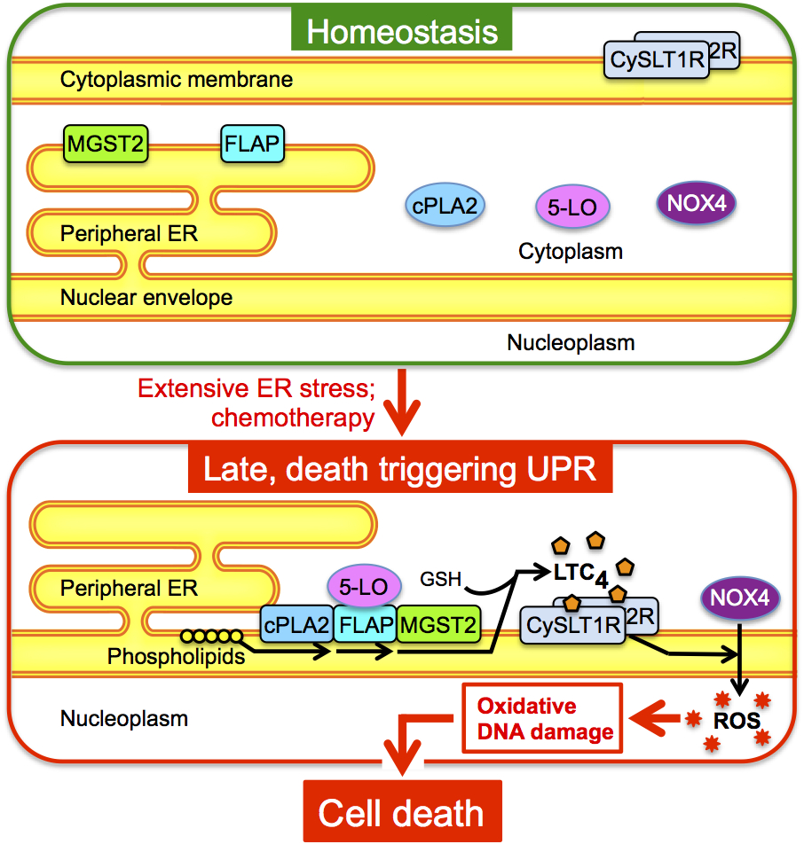

**Figure 1**. The LTC4 biosynthetic machinery and its receptors translocate and co-localize at the nuclear envelope in response to ER stress. As a result NOX4 is activated, generating ROS, which cause DNA damage and cell death.

1. **The MGST2-LTC4 Pathway Mediates Chemotherapy-triggered Cell Death.**

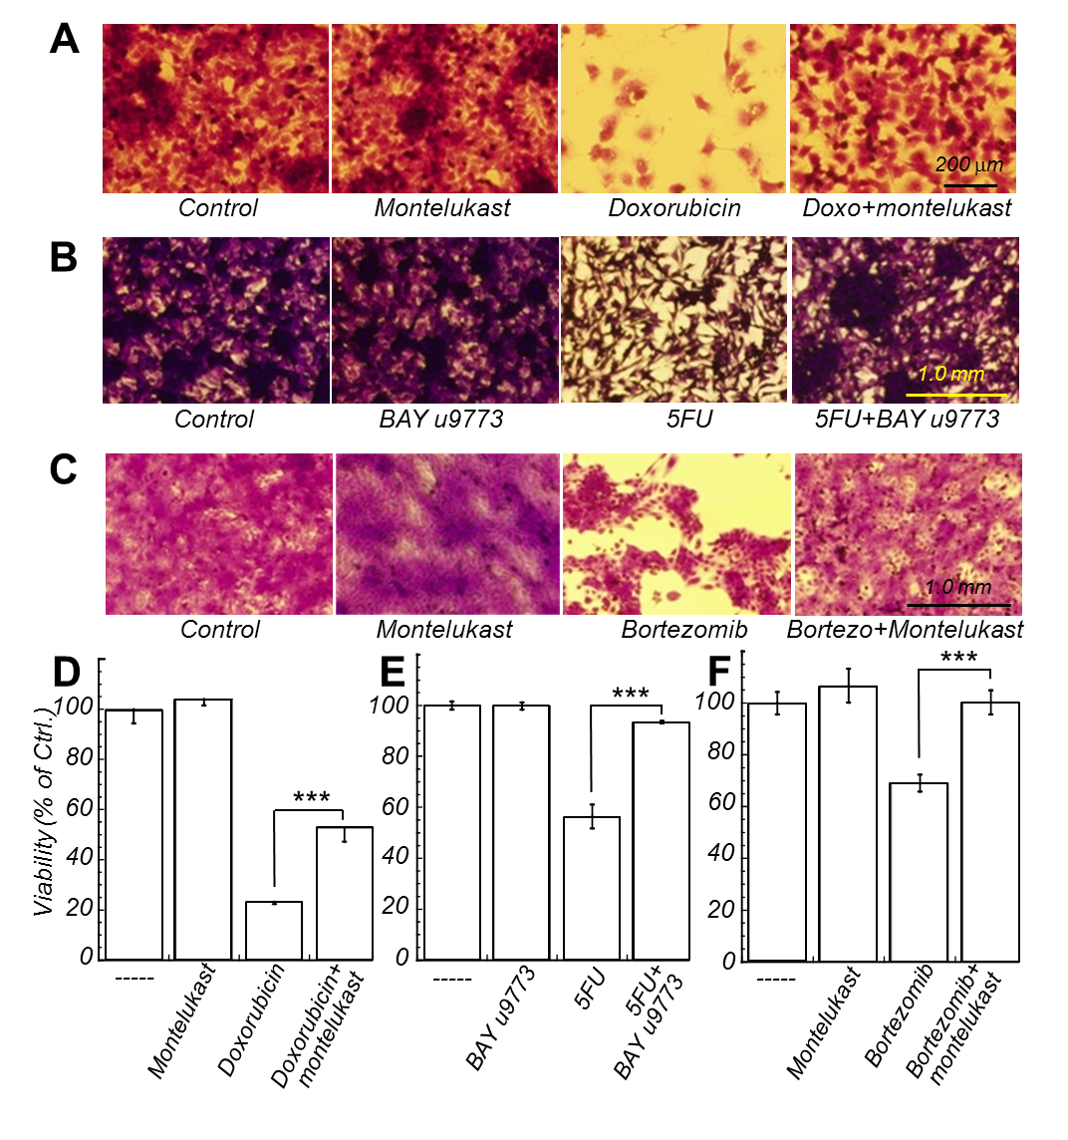

**Figure 2**. (A) Human WISH cells were treated with vehicle (Control), montelukast (2.5 µM), or doxorubicin (3 µM) in the presence or absence of montelukast for 72 h. The plates were then stained with Crystal violet.

(B) Mouse B16 cells were treated with vehicle (Control), BAY u9773, or 5FU in the presence or absence of BAY u9773 for 24 h. The plates were then stained with Crystal violet.

(C) Human HaCaT pre-keratinocytes were treated with vehicle (Control), montelukast, or bortezomib in the presence or absence of montelukast for 24 h. The plates were then stained with Crystal violet.

(D, E, F) Relative viability of the cultures shown in B, C, & D, respectively. Doxorubicin: N=4, ***p< 0.001. 5FU: N=3, p < 0.0002. Bortezomib: N=3, p < 0.004.

1. **MGST2 Deficiency Attenuates Chemotherapy Triggered Death**

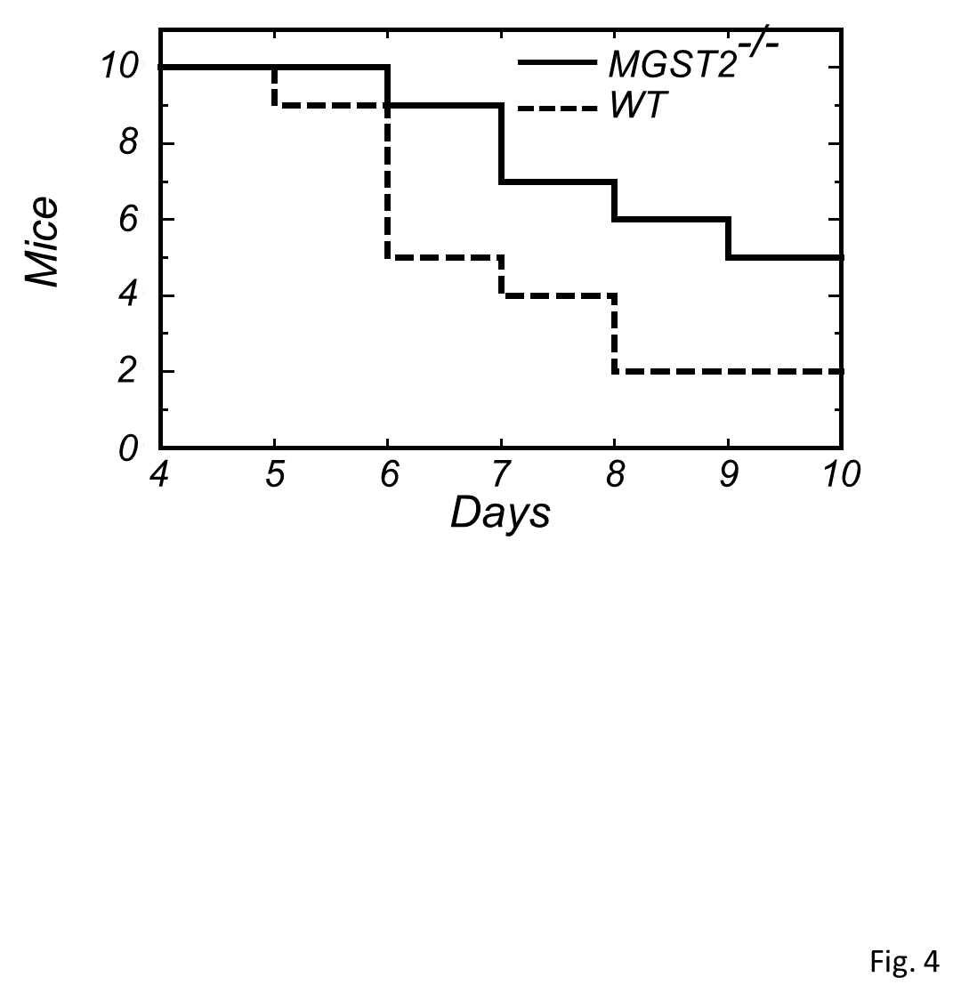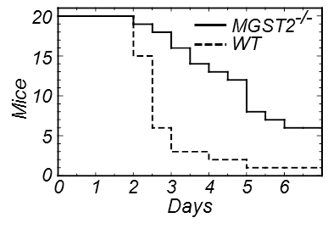

**Figure 3**. (A) Survival of WT and *MGST2*-deficient mice (10/group) to which doxorubicin (20 mg/kg) was administered ip daily for three consecutive days. (B) Survival of tunicamycin wt vs. MGST2-/-.

1. **Pranlukast Protects Against Tunicamycin Mediated Toxicity *in vivo*.**

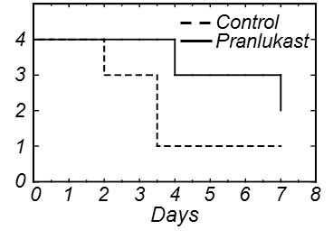

**Figure 4**. Survival of WT tunicamycin treatment ± pranlukast

1. **Pranlukast Attenuates Simvastatin Triggered Cell Death**

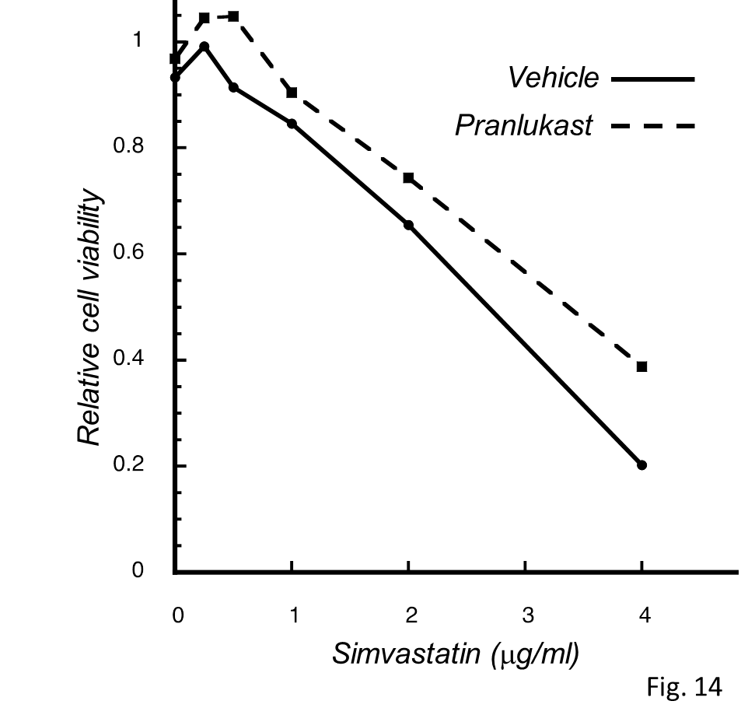

**Figure 5**. Survival of WT tunicamycin treatment ± pranlukast

**For additional information please contact:**

Dr. Shay Sela

VP Business Development Life Sciences

Tel: +972.8.9344095

Email: [Shay.Sela@weizmann.ac.il](mailto:Maya.Orlev@weizmann.ac.il)